Topic—Comparing Bubble Sort and Merge Sort Algorithm
Tripti Vishwakarma
Colorado State University Global
Course Code: CSC 506 -1
Dr. Dong Nguyen
Dec 1, 2024

Title: Enhancing Efficiency in Healthcare Patient Record Systems: A Comparative Analysis of Bubble Sort and Merge Sort Algorithms

Introduction
The management of patient records in healthcare settings is a vital component of ensuring the delivery of timely, accurate, and efficient care. Electronic Health Records (EHR) systems are increasingly being used to store and retrieve patient data, facilitating better decision-making and care coordination. However, the efficiency of these systems is often hindered by the time required to sort and retrieve large datasets. Sorting algorithms are integral to the performance of EHR systems, influencing everything from patient searches to report generation (McGilvray, 2017).
This paper investigates two common sorting algorithms, Bubble Sort and Merge Sort, by comparing their efficiency in the context of healthcare systems. By understanding how each algorithm performs, healthcare providers can optimize their systems to reduce delays and improve patient outcomes. This analysis includes a discussion on time complexity, optimal conditions for each algorithm, and the challenges faced during the development of such systems (Cormen et al., 2009).

Purpose of the Study
The primary purpose of this study is to analyze the performance of Bubble Sort and Merge Sort algorithms in healthcare patient record systems. Specifically, we aim to:
- Compare the algorithms' time complexity in relation to patient data size (McWilliams, 2018).
- Identify optimal conditions for their use within a medical records context (Kleinberg & Tardos, 2006).
- Highlight challenges faced when sorting medical data, including issues of scalability and efficiency (McGilvray, 2017).

Comparison of Bubble Sort and Merge Sort Algorithms
Bubble Sort Algorithm
Bubble Sort is one of the simplest sorting algorithms, known for its ease of implementation. It works by repeatedly stepping through the list, comparing adjacent elements and swapping them if they are in the wrong order. This process is repeated until the list is sorted (McGilvray, 2017).
Bubble Sort Algorithm:
def bubbleSort(arr):
n = len(arr)
for i in range(n):
swapped = False
for j in range(0, n-i-1):
if arr[j] > arr[j+1]:
arr[j], arr[j+1] = arr[j+1], arr[j] # Swap
swapped = True
if not swapped:
break # Optimized to stop if the array is already sorted
return arr


Execution:
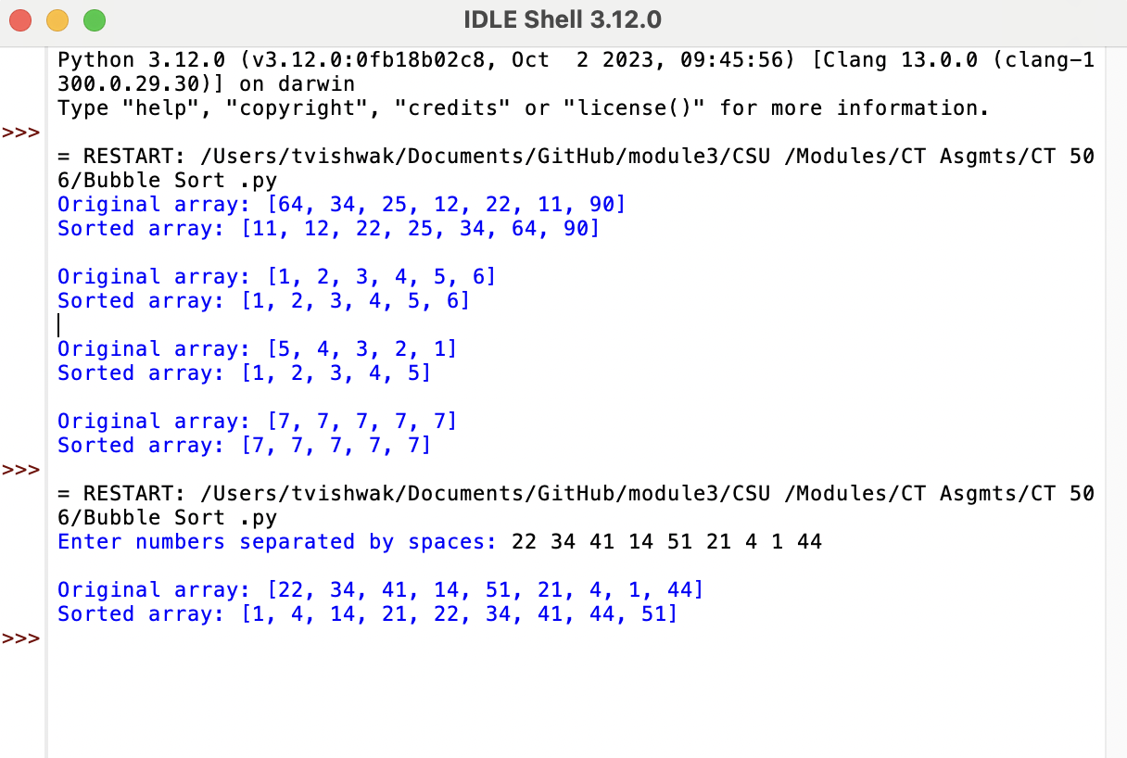
Time Complexity:
- Best Case: O(n) (when the list is already sorted)
- Worst Case: O(n^2) (when the list is in reverse order)
- Average Case: O(n^2) (Cormen et al., 2009)

Merge Sort Algorithm
Merge Sort is a divide-and-conquer algorithm. It divides the list into two halves, recursively sorts each half, and then merges the sorted halves into a single sorted list (Kleinberg & Tardos, 2006).
Merge Sort Algorithm:
def mergeSort(arr):
if len(arr) > 1:
mid = len(arr) // 2
left_half = arr[:mid]
right_half = arr[mid:]

mergeSort(left_half) # Recursive call on left half
mergeSort(right_half) # Recursive call on right half

i = j = k = 0
# Merging the sorted halves
while i < len(left_half) and j < len(right_half):
if left_half[i] < right_half[j]:
arr[k] = left_half[i]
i += 1
else:
arr[k] = right_half[j]
j += 1
k += 1

# If any elements remain in either half, add them to the array
while i < len(left_half):
arr[k] = left_half[i]
i += 1
k += 1
while j < len(right_half):
arr[k] = right_half[j]
j += 1
k += 1
return arr
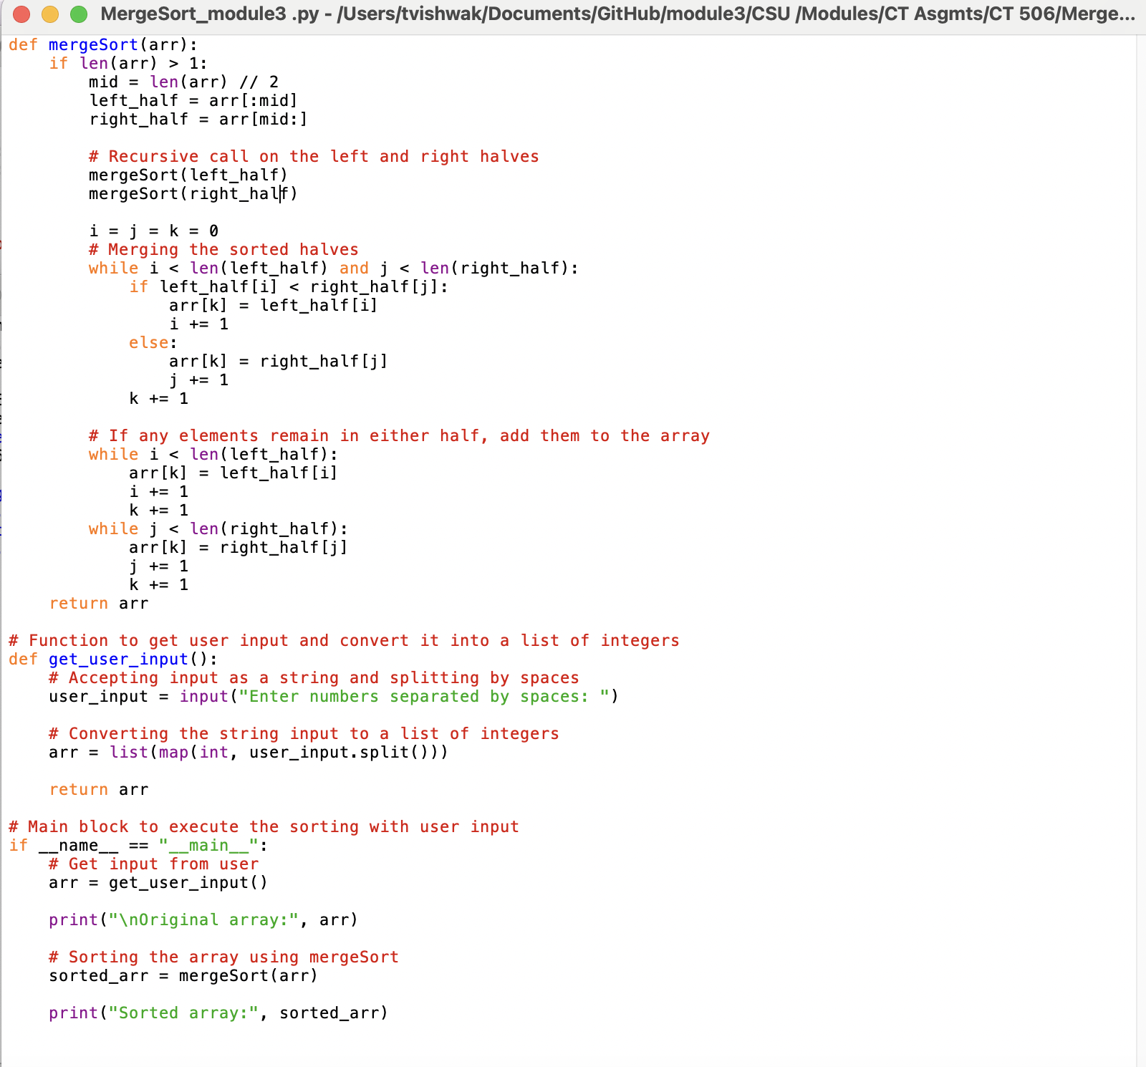

Execution:
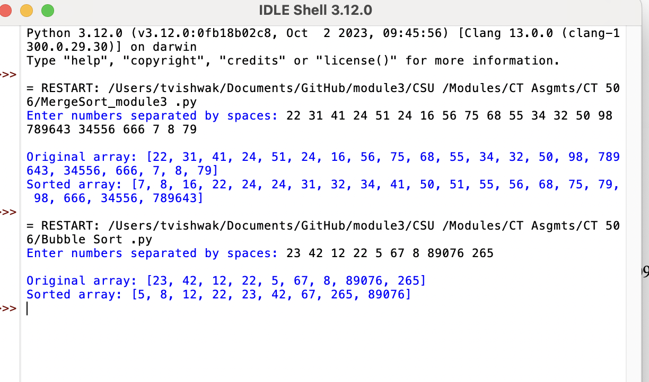
Time Complexity:
- Best, Worst, and Average Case: O(nlogn) (Cormen et al., 2009)

Analysis of Time Complexity
In a hospital or healthcare setting, patient records could involve thousands of records with multiple attributes (e.g., patient ID, name, age, treatment history). Sorting these records efficiently is crucial for performance. Sorting inefficiencies can directly affect the response times of healthcare applications, potentially delaying crucial decisions.
- Bubble Sort is not suitable for large datasets due to its O(n^2) time complexity. This quadratic complexity can lead to significant delays when sorting large patient record databases, especially during peak times when quick access to patient data is necessary (McGilvray, 2017).
- Merge Sort, with its O(n log n) time complexity, is much more scalable. It will handle larger datasets much more efficiently, making it a better choice for a medical records system that requires high performance even under heavy data loads (Kleinberg & Tardos, 2006).

Optimal Conditions in Healthcare Context
- Bubble Sort might be suitable in scenarios where the dataset is small or almost sorted. For example, if there are only a few patients to sort or the system mostly requires re-sorting of records that have changed slightly (such as adding a few new patients), Bubble Sort could be effective (McWilliams, 2018).
- Merge Sort is optimal for large-scale healthcare systems where the number of records is substantial. Given its predictable performance (O(nlogn)), Merge Sort is better suited for scenarios like:
  - Sorting large patient databases based on different attributes (e.g., age, medical history).
  - Performing batch updates or sorting records periodically in the backend (McGilvray, 2017).

Critical Problems in Healthcare Sorting Systems
Sorting medical data can be complex due to the following challenges:
- Large volumes of data: Healthcare systems often deal with a vast number of records that need to be sorted in real-time.
- Privacy concerns: Patient data must be sorted in compliance with regulations such as HIPAA, which adds constraints on how data is processed and accessed (McWilliams, 2018).
- Real-time access: Sorting should be efficient enough to ensure that medical staff can access up-to-date patient information quickly.
- Multifaceted queries: Sorting not only needs to handle patient names or IDs but also complex queries, such as medical conditions, treatment plans, and medication schedules (Kleinberg & Tardos, 2006).

Justification for Chosen Data Structures
The data structure chosen for storing patient records in an EHR system can significantly impact sorting efficiency:
- Arrays or Lists: Simple and suitable for Bubble Sort but inefficient for large datasets (McGilvray, 2017).
- Linked Lists: These may offer efficient insertion but have slower random access times, making them less suitable for large-scale sorting.
- Balanced Trees (e.g., Red-Black Tree, AVL Tree): These can help maintain sorted order dynamically, providing efficient insertions, deletions, and searches (Cormen et al., 2009).
For larger datasets, balanced trees or even hashing might be preferred over simple arrays or lists for fast access and sorting (McWilliams, 2018).

External Factors Affecting Efficiency
Several external factors can influence the efficiency of sorting algorithms in a hospital setting:
- Hardware limitations: The amount of RAM and CPU power available will impact the algorithm’s performance.
- Database size: As the database grows, algorithms like Merge Sort will outperform Bubble Sort.
- Network bandwidth: When accessing records across a network, the time taken to retrieve data will impact sorting efficiency (McGilvray, 2017).

Lower Bound and Practical Limitations
The theoretical lower bound for sorting algorithms is O(nlogn), which means that no comparison-based sorting algorithm can perform better than this in the average or worst case. Merge Sort meets this lower bound, while Bubble Sort does not, making it unsuitable for large-scale applications (Cormen et al., 2009).

Obstacles Faced During Development
During the development of this comparative study, several obstacles were encountered:
- Handling Large Data Volumes: One significant challenge was simulating large datasets to evaluate the efficiency of the sorting algorithms. The complexity of managing and manipulating large datasets posed difficulties, particularly when testing Bubble Sort, as it became impractical with datasets of even moderate size.
- Optimizing for Real-Time Use: While both sorting algorithms were easy to implement, optimizing them for real-time use in a healthcare setting proved challenging. Real-time data processing demands low latency and high efficiency, which is difficult to achieve with slower algorithms like Bubble Sort.
- Scalability Issues: During testing, the Merge Sort algorithm showed better scalability, but even then, some performance bottlenecks were observed in systems with extremely large volumes of records. Implementing an efficient memory management strategy was crucial to mitigate these issues.
- Legal and Ethical Concerns: Handling patient data, even for experimental purposes, required compliance with strict data privacy laws (e.g., HIPAA in the U.S.). Ensuring that test data met these privacy standards was an unexpected but necessary challenge.

Skills Acquired
Through this study and its challenges, several key skills were developed:
- Algorithm Optimization: The experience gained from optimizing sorting algorithms for real-time use in healthcare environments was invaluable. This included understanding the limitations of different algorithms and the need for more scalable solutions.
- Data Management: The ability to handle large datasets, simulate realistic healthcare environments, and implement efficient data storage techniques was a critical skill acquired through this project.
- Problem-Solving: Overcoming obstacles related to performance and scalability helped strengthen problem-solving skills, particularly in identifying bottlenecks and implementing practical solutions.
- Regulatory Compliance Knowledge: Gaining a deeper understanding of data privacy regulations, such as HIPAA, was essential in ensuring that the development process complied with legal requirements, even during testing phases.

Conclusion
In healthcare systems where data volume and the need for real-time access are crucial, sorting algorithms play a pivotal role. While Bubble Sort is simple and easy to implement, it is inefficient for large datasets commonly found in healthcare environments. Merge Sort, with its O(nlogn) time complexity, is more appropriate for managing patient records in large-scale systems. By understanding the strengths and weaknesses of each algorithm, healthcare providers can make informed decisions about optimizing patient record systems, improving both efficiency and quality of care (McWilliams, 2018).

References
Cormen, T. H., Leiserson, C. E., Rivest, R. L., & Stein, C. (2009). Introduction to Algorithms (3rd ed.). MIT Press.
Kleinberg, J., & Tardos, É. (2006). Algorithm Design. Addison-Wesley.
McGilvray, S. (2017). Data Structures and Algorithms in Python. Wiley.
McWilliams, M. (2018). Healthcare Data Management and Analytics. Springer.

